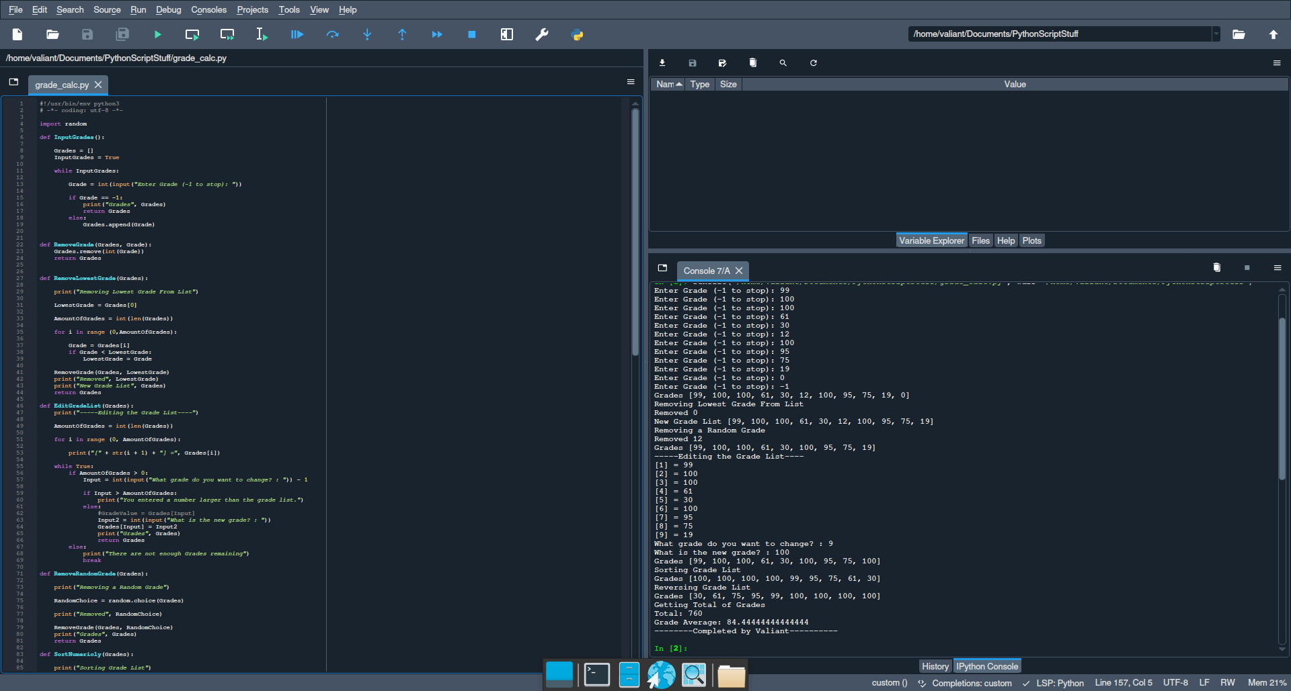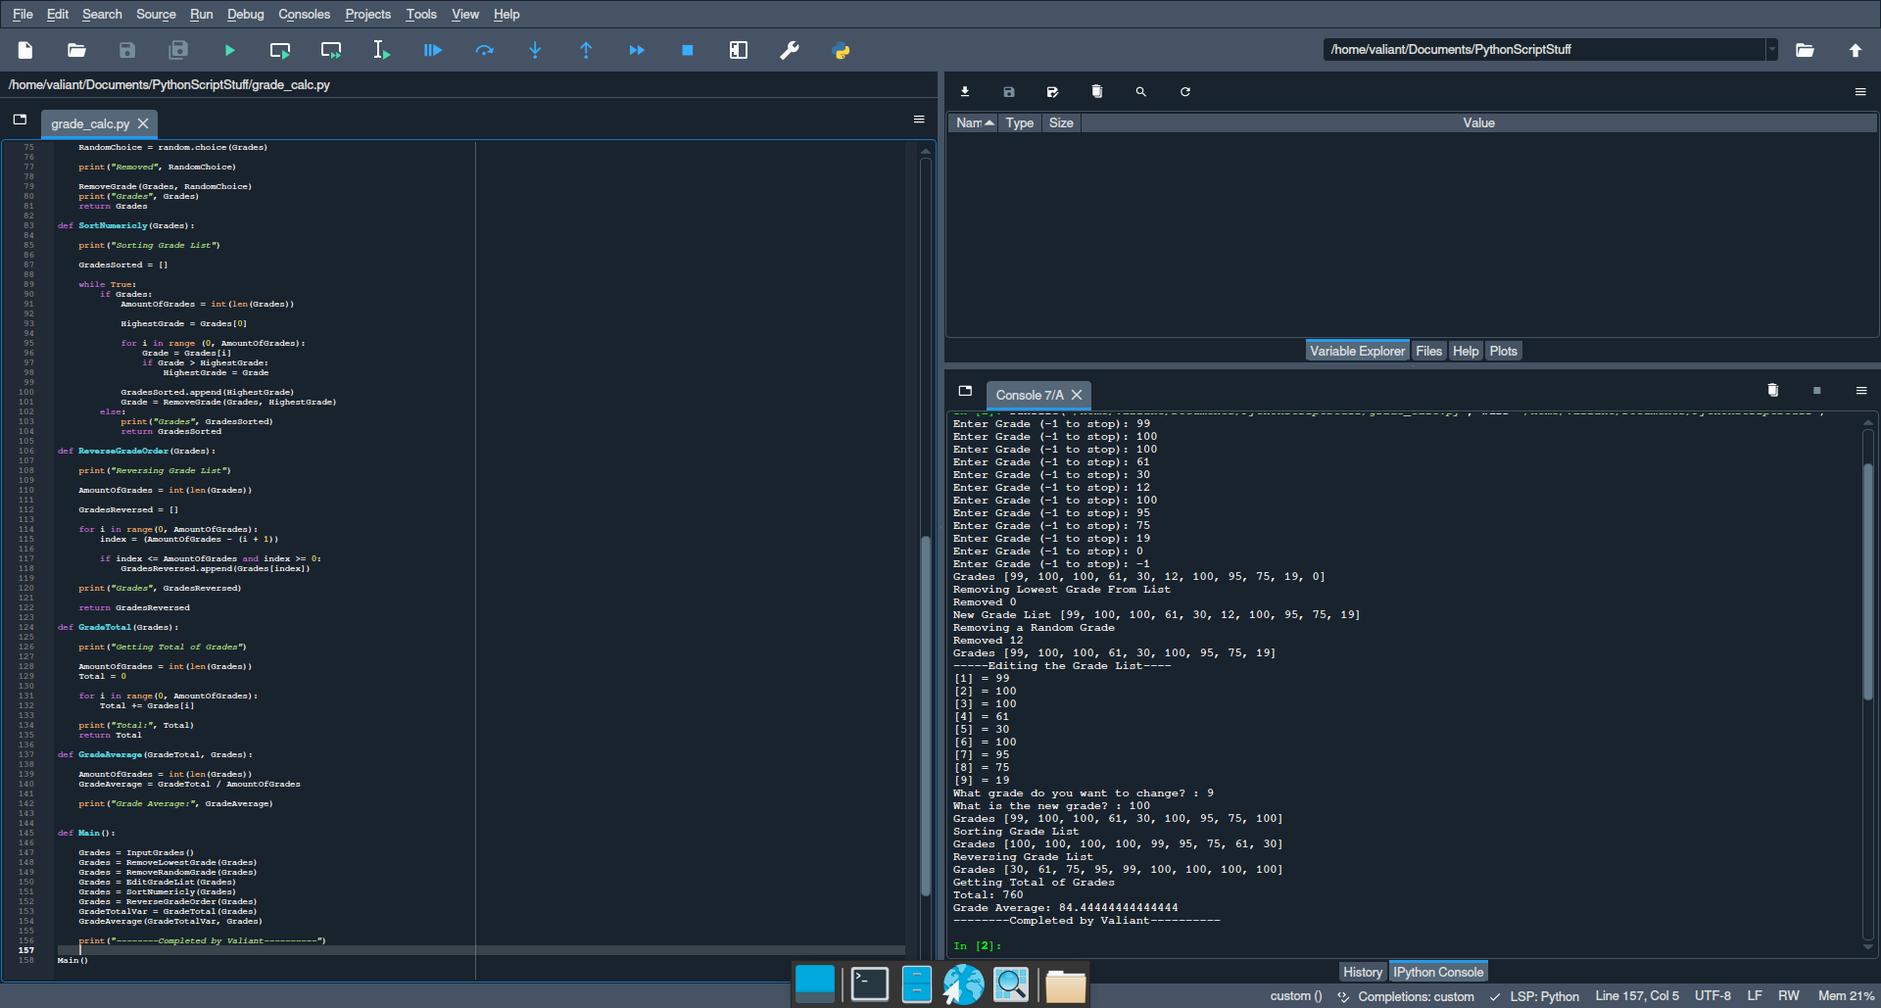import random

def InputGrades():

Grades = []

InputGrades = True

while InputGrades:

Grade = int(input("Enter Grade (-1 to stop): "))

if Grade == -1:

print("Grades", Grades)

return Grades

else:

Grades.append(Grade)

def RemoveGrade(Grades, Grade):

Grades.remove(int(Grade))

return Grades

def RemoveLowestGrade(Grades):

print("Removing Lowest Grade From List")

LowestGrade = Grades[0]

AmountOfGrades = int(len(Grades))

for i in range (0,AmountOfGrades):

Grade = Grades[i]

if Grade < LowestGrade:

LowestGrade = Grade

RemoveGrade(Grades, LowestGrade)

print("Removed", LowestGrade)

print("New Grade List", Grades)

return Grades

def EditGradeList(Grades):

print("-----Editing the Grade List----")

AmountOfGrades = int(len(Grades))

for i in range (0, AmountOfGrades):

print("[" + str(i + 1) + "] =", Grades[i])

while True:

if AmountOfGrades > 0:

Input = int(input("What grade do you want to change? : ")) - 1

if Input > AmountOfGrades:

print("You entered a number larger than the grade list.")

else:

#GradeValue = Grades[Input]

Input2 = int(input("What is the new grade? : "))

Grades[Input] = Input2

print("Grades", Grades)

return Grades

else:

print("There are not enough Grades remaining")

break

def RemoveRandomGrade(Grades):

print("Removing a Random Grade")

RandomChoice = random.choice(Grades)

print("Removed", RandomChoice)

RemoveGrade(Grades, RandomChoice)

print("Grades", Grades)

return Grades

def SortNumericly(Grades):

print("Sorting Grade List")

GradesSorted = []

while True:

if Grades:

AmountOfGrades = int(len(Grades))

HighestGrade = Grades[0]

for i in range (0, AmountOfGrades):

Grade = Grades[i]

if Grade > HighestGrade:

HighestGrade = Grade

GradesSorted.append(HighestGrade)

Grade = RemoveGrade(Grades, HighestGrade)

else:

print("Grades", GradesSorted)

return GradesSorted

def ReverseGradeOrder(Grades):

print("Reversing Grade List")

AmountOfGrades = int(len(Grades))

GradesReversed = []

for i in range(0, AmountOfGrades):

index = (AmountOfGrades - (i + 1))

if index <= AmountOfGrades and index >= 0:

GradesReversed.append(Grades[index])

print("Grades", GradesReversed)

return GradesReversed

def GradeTotal(Grades):

print("Getting Total of Grades")

AmountOfGrades = int(len(Grades))

Total = 0

for i in range(0, AmountOfGrades):

Total += Grades[i]

print("Total:", Total)

return Total

def GradeAverage(GradeTotal, Grades):

AmountOfGrades = int(len(Grades))

GradeAverage = GradeTotal / AmountOfGrades

print("Grade Average:", GradeAverage)

def Main():

Grades = InputGrades()

Grades = RemoveLowestGrade(Grades)

Grades = RemoveRandomGrade(Grades)

Grades = EditGradeList(Grades)

Grades = SortNumericly(Grades)

Grades = ReverseGradeOrder(Grades)

GradeTotalVar = GradeTotal(Grades)

GradeAverage(GradeTotalVar, Grades)

print("--------Completed by Valiant----------")

Main()